

FC6P01 Project

Final Report

‘Mart’ - An Online Food Distribution Network system - A web based Food Delivery System

Name: Chamith Chathuka Wickramarathna

ID Number: 16033954

Date: 02 April 2017

First Supervisor: Ms. Theja Nadeeshani Perera Ilanperuma

Second Supervisor: Mr. Thilina Ranathunga

# Declaration

**Module: FC6P01 Deadline: 30/05/2017**

**Module Leader: Mr Nishan Sembacuttiaratchy Student ID: 16033954**

PLAGIARISM

You are reminded that there exist regulations concerning plagiarism. Extracts from these regulations are printed below. Please sign below to say that you have read and understand these extracts:

(signature:)______________________ Date: 23/06/17

This header sheet should be attached to the work you submit. No work will be accepted without it.

Extracts from University *Regulations* onCheating, Plagiarism and Collusion

Section 2.3: "The following broad types of offence can be identified and are provided as indicative examples…

1. Cheating: including taking unauthorised material into an examination; consulting unauthorised material outside the examination hall during the examination; obtaining an unseen examination paper in advance of the examination; copying from another examinee; using an unauthorised calculator during the examination or storing unauthorised material in the memory of a programmable calculator which is taken into the examination; copying coursework.
2. Falsifying data in experimental results.
3. Personation, where a substitute takes an examination or test on behalf of the candidate. Both candidate and substitute may be guilty of an offence under these Regulations.
4. Bribery or attempted bribery of a person thought to have some influence on the candidate's assessment.
5. Collusion to present joint work as the work solely of one individual.
6. Plagiarism, where the work or ideas of another are presented as the candidate's own.
7. Other conduct calculated to secure an advantage on assessment.

(viii) Assisting in any of the above.

Some notes on what this means for students:

1. Copying another student's work is an offence, whether from a copy on paper or from a computer file, and in whatever form the intellectual property being copied takes, including text, mathematical notation and computer programs.

2. Taking extracts from published sources *without attribution* is an offence. To quote ideas, sometimes using extracts, is generally to be encouraged. Quoting ideas is achieved by stating an author's argument and attributing it, perhaps by quoting, immediately in the text, his or her name and year of publication, e.g. "e = mc2 (Einstein 1905)". A *references* section at the end of your work should then list all such references in alphabetical order of authors' surnames. (There are variations on this referencing system which your tutors may prefer you to use.) If you wish to quote a paragraph or so from published work then indent the quotation on both left and right margins, using an italic font where practicable, and introduce the quotation with an attribution.

# Abstract

This Report is prepared to address A web based Food Delivery System solution for restaurants. Aims to conquer and redefine the current distribution network in Sri Lanka by delivering almost anything you need straight to your doorstep within approximately 30-60 minutes. This system will help for small restaurants and groceries which currently do not have an online system and own product delivery system. Partnering with this system will help those restaurants and groceries to expand their sales and market share. At initial stage of the document gives the reader clear idea about the background of the problem. Afterwards this gives an idea of the proposed system and how to overcome from the problem with given solution. Then this document provides and idea about a system construction process and some screen shots from the current process of the system. At last this report gives list of references used to prepare the document for further reference.

Acknowledgement

I thank to Mrs Mahesha Thejani and Mrs Theja Nadeeshani, for guiding me to do the project and supervising me to to the end of the project with their suggestions.

Also my thank goes to Mr. Thilina Ranathunga for giving we support from the technical side and introducing new technologies used and also sharing his experience with using those technologies.

I also thank to Mr. Nishan Sembacuttiaratchy for conducting us with several project guidance sessions and sharing techniques for writing documentation which really helped me when I was preparing the documentation.

Finally, My thank goes to my classmates who shared their ideas on my project and helpmed me to develop the documantation

Contents

Declaration 2

Abstract 3

Introduction 5

Background 6

Work Completed 8

Organization, According to the Gantt chart mentioned in previous page so far author was able to completed most of the tasks up to date. 9

Feasibility Study 9

Requirement Specification 11

Class Diagram 13

Entity Relationship Diagram 19

Further Work 20

Bibliography 21

# Introduction

Today, with busy life style of the people, and with the development of new technology people always trying to save their time and put that effort to do something useful or even they spent more time with their family members. These technologies based systems and devices are helping to improve the efficiency and do the traditional task in new innovative methods. This new technology supports individuals to improve their life style and business to increase their sales and earn revenue with expanding market share. (von Breitenbuch, 2004)

The ecommerce can be defined as a modern business methodology that can be address then needs of organizations, merchants and consumers to cut the costs while improving the quality of goods and services and increasing the speed of service diversity by using the internet. (Meier and Stormer, 2009)

This system providing service for Merchants and customers. This system is providing SaaS for its end users. SaaS is a simply software which is delivered from s server remote location your desktop it is an application hosted on Remote server. Software uses its own interfaces, designed to provide a special characteristics for the software. Some of the SaaS applications require to pay a subscription fee from its end users, but the proposed system only taking a small commission fee from the server, SaaS application requires active internet connection to connect to this web site so if there is no internet connection, there will be no application for client to connect, that is the main disadvantage of this system, but currently almost everyone has access to internet this will be a not a problem.(Wohl, 2008)

Online ordering of foods represents 30% of daily takeaway ordering according to Cowen and Company Research Report and it is now rapidly growing with the due to its convenience, correctness of ordering and no waiting queues. Studies show about 69% of customers using their mobile devices for online food ordering.

As the first step off the document ‘background’ section author gives clear idea about the current difficulties faced by the customers face when doing traditional take away shopping and difficulties faced by small restaurant and grocery owners when delivering food to customers and expanding their business. How to overcome for these problems by analysing those problems and over solution will help sellers to overcome from it. In addition to those parts, this section will provide details of the technologies that the system is using and the reason for selecting those technologies. It will also give a concise idea on implementation of the system.

Next section of the document will provide information on the work completed up to now. This report will be given tasks which were addressed to pre given Gantt chart in the project proposal and feasibility study, Wire frame design and some of the UML diagrams related to the project and the ER diagram of the project.

# Background

Mart is food delivery network which connects merchants and customers. Small shop owners and Restaurant owners must spend additional investments to provide a delivery service for its customers, which is big barrier for the business to grow and reach its target. Most of the small restaurants or shops do not have their own web site for their customers to reach.

When we consider form the customer’s perspective Customers have to visit the physical place to buy their favourite food or purchase food items for their needs. It is a time consuming and stressful work this generation.

Mart gives a better solution for by bridging these two types of customers by giving their platform for their delivery needs, marketing needs and sales expansion needs from the merchant side and giving quick delivery at lower cost from the client side.

Currently “Mart” is operated by a phone system and manually takes the order over the phone and then contacts the nearest delivery person and provides delivery details to him again over the phone and receiving the cash on delivery method. Customers need to provide their address every time they place and order. After purchasing the ordered items from the customer mentioned restaurant or shop.

Since this process make much more errors at the delivery stage since everything is done over the phone customers are complaining for wrong orders and that make the process more complex and financial loss for the company. Increased phone charges directly affecting to the profit of ‘Mart’.

To overcome from these problems Author suggested an online platform for Mart and where gives the small restaurant and shop owners to maintain their profiles by partnering with ‘ Mart’ and after registering with systems customers can order and their favourite food products and grocery items from their devices, after placing and order Restaurant owner automatically gets the notification, and if that restaurant or the grocery request delivery method by ‘Mart’ Mart agent will pick the order from the restaurant or grocery with short amount of time and deliver for the customer provided address.

Since this a ecommerce site this site revenue generation is done by getting 5% commission from the total value of the each order customer placed through this system, also ‘Mart’ standard delivery charges will be applied for the customers who select ‘Mart Delivery’ option.

Developer used Spring Boot frame work to develop the backend of the web application, for the Database development developer used MySQL 5.5 Community Edition server. Hibernate 5 is used to object relational mapping. Materize CSS is an Open Source responsive fronend

This system is developed using the Agile methodology since the requirements of the client ‘Mart’ is changing rapidly. Requirements of the mart business process are broken down to user stories and now the most priority use cased are developed in the back end.

Architecture of the system developed as MVC implemented 3 tier architecture. Use of hybrid is MVC pattern do not describe hot to best design and data access and how to manage the complexity that occur in the system. (Rawsthorne, Rawsthorne and profile, 2017)

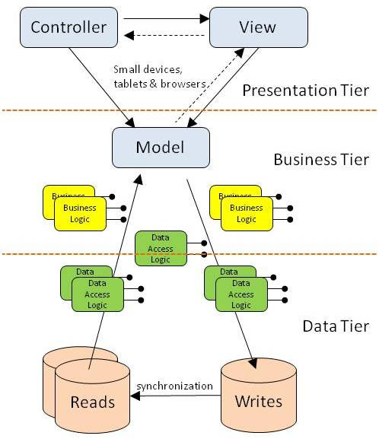

(Anon, 2017)

# Work Completed

Developing a web based software system on a given time schedule is very important as it makes considerable impact to the organization, According to the Gantt chart provided with the project proposal document(also mentioned below) several sequential processes given before the actual implementation user training process.

|  |  |  |  |  |  |  |  |  |  |  |  |  |  |  |  |  |  |  |  |  |  |
| --- | --- | --- | --- | --- | --- | --- | --- | --- | --- | --- | --- | --- | --- | --- | --- | --- | --- | --- | --- | --- | --- |
| **Start (**30/12/2016) End(30/05/2017) | | | | | | | | | | | | | | | | | | | |  | |
|  | 1 | 2 | 3 | 4 | 5 | 6 | 7 | 8 | 9 | 10 | 11 | 12 | 13 | 14 | 15 | 16 | 17 | 18 | 19 | | 20 |
| 1. **Requirement analysis**  * Interviews * Observation of processes * Identifying risks * Define outline of requirement |  |  |  |  |  |  |  |  |  |  |  |  |  |  |  |  |  |  |  | |  |
| 1. **System design**  * Assign requirements to increments * Define System Architecture * Identify relationship among increment |  |  |  |  |  |  |  |  |  |  |  |  |  |  |  |  |  |  |  | |  |
| 1. **System development and testing**  * Development system user Story * Validate * Integrate * Validate system * Get user feedback |  |  |  |  |  |  |  |  |  |  |  |  |  |  |  |  |  |  |  | |  |
| 1. **Integrate and deliver final system** |  |  |  |  |  |  |  |  |  |  |  |  |  |  |  |  |  |  |  | |  |
| 1. **Project Documentation** |  |  |  |  |  |  |  |  |  |  |  |  |  |  |  |  |  |  |  | |  |
| 1. **User training and maintenance** |  |  |  |  |  |  |  |  |  |  |  |  |  |  |  |  |  |  |  | |  |

(Gantt Chart Provided with the project proposal)

# Organization, According to the Gantt chart mentioned in previous page so far author was able to completed most of the tasks up to date.

Preparation of the project proposal

Analysing the current requirements and Feasibility Study.

Database conceptual Design including ER Diagram and Physical Design

Completed the related UML diagrams use case diagram.

Develop system backend with basic CRUD operations passing to backend as JSON objects, and retrieving the output as JSON and some of the interfaces.

Following chapters will describe the work that have already done in detail.

## Feasibility Study

What is expected from a feasibility study is that verifying the system is worth implementing and whether it can be implemented within the given timeline and budget (Sommerville, 2010). However, the final outcome of the feasibility study is deciding on whether or not the system development is continued. By doing this in the correct way the project a lot of time, money and resources can be saved.

There are many different types of feasibility studies. Prior to starting this project the following feasibility studies were done:

* Technical feasibility
* Schedule Feasibility
* Economic feasibility
* Operational feasibility

**Technical feasibility**

Technical feasibility is compatibility of technology we are using resources at hand in implementing the project. Technical resources considered in this project are the technical knowledge, capacity of hardware devices and capability of software. Further assessment on different types of frontend and backend platforms were done before choosing a specific platform.

**Schedule Feasibility**

Schedule feasibility is analysing whether the system can be completed within the timeline given. According to the schedule feasibility of this system, a decision was made to work part-time on the project implementation process.

**Economic Feasibility**

Economic feasibility is analysing the cost and the revenue of the project. In this project one of the main concerns was the affordability of additional software and hardware needed to implement the project. Keeping the project within the given budget was challenging as well. However it was decided that the cost of hardware and software needed to implement the system.

**Operational Feasibility**

Operational Feasibility involves testing the operational scope of the system. When the operational scope of the system is high, the usability of the system will also be high. Without doubt the system is highly user friendly with fully GUI. But it was decided it would be better to conduct a training program to make users more comfortable and to get the maximum efficiency of the system.

# Requirement Specification

According to the gathered requirements the currently the system is using Velocity rendering engine for the demonstration purpose of the system user interfaces and developer will move to Angular JS Client side framework later. From the back end validation part for form details are done preventing the possible errors in the system.

Hardware Requirements

|  |  |
| --- | --- |
| **Client Side** | **Server Side** |
| Device with Windows, Linux or MacOS ,Android | Ubuntu 14.04 Server Edition |
| Google Chrome 4.0,Microsoft Edge 12.0, Firefox 3.5, Safari 4.0 or above version | Apache2 Server, Apache Tomcat 7 and MySQL Server 5.5 |
| 512 MB RAM | 512MB RAM |
| 5GB free Storage | 20GB free Storage |
| Internet Connection | High speed Internet Connection with  Static IP  Domain name(optional) |

Functional Requirements

Below use case diagram provides the functional requirements identified during the Requirements Analysis Stage. Up to now System developer has identified 3 major user roles that in the system. They are,

1. Mart Admin User
2. Shop Owner(Merchant)
3. Customer
4. Courier Agent

Mart Admin user is the user who involve and operate the system with lot of privileges, Mart Admin user is an Employee of a Mart Organization, so that user has access to almost everything.

Shop Owner is user who partner with Mart system and publish their products on the Mart platform.

Customer is the user who sign up with the system and order products through the Mart platform by going through different products listed by the Shop owners and make payments for them

Courier user agent is the user who pick the delivery order to the customer when a customer place an order through the system and update the payment status, and order delivery status.

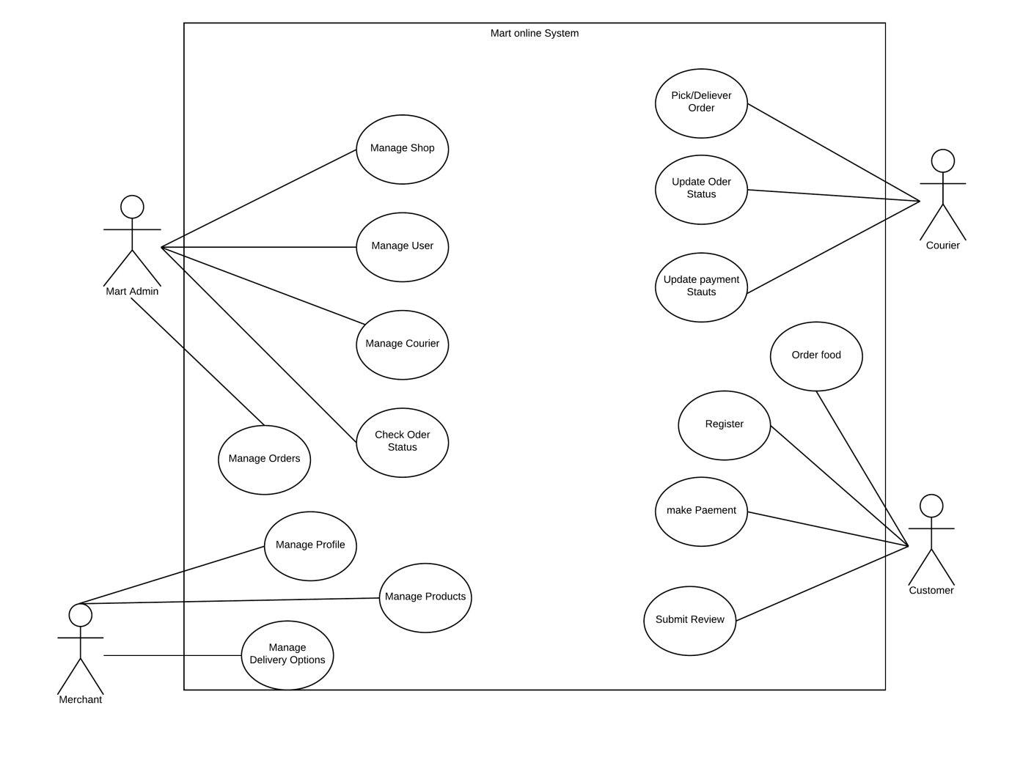

Figure 1 use Case Diagram - Mart

## Class Diagram

Due to the complexity of the class diagram to make it clear view of the classes below the classes are shown separately and finally the complete class diagram is placed.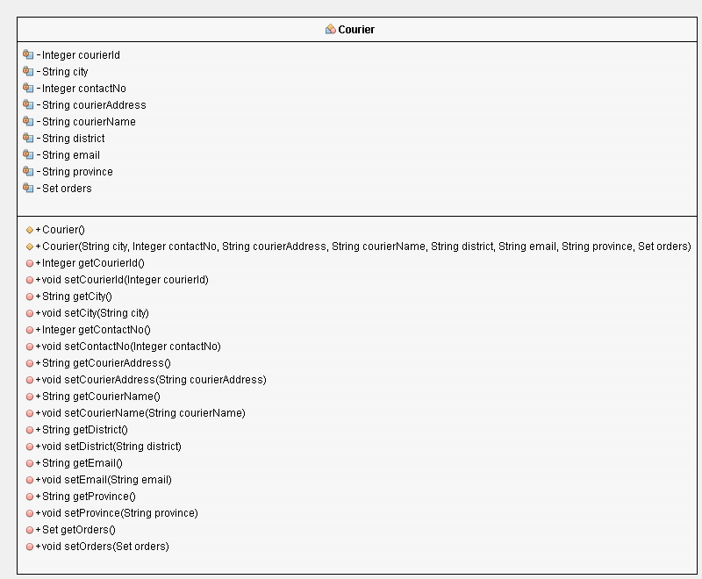

Figure 2 Courier Class

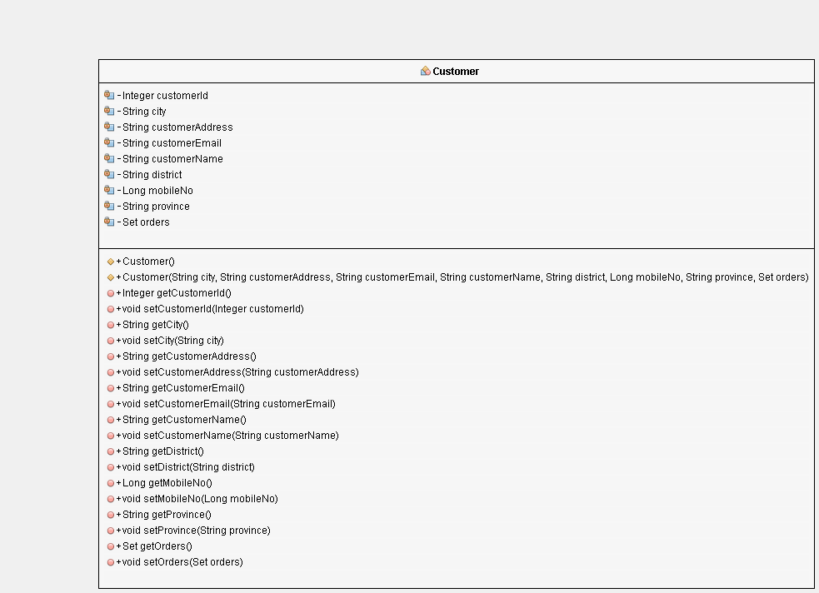

Figure 3Customer Class

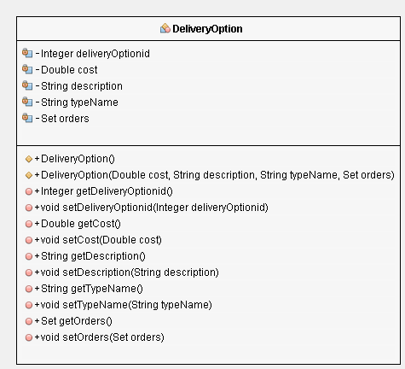

Figure 4 Delivery Option

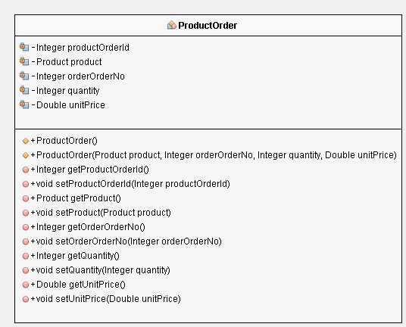

Figure 5 Place Order

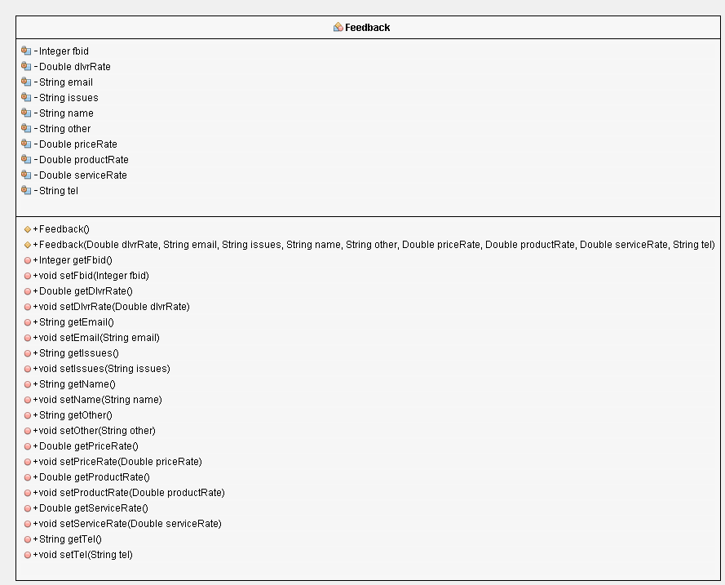

Figure 6 Feedback

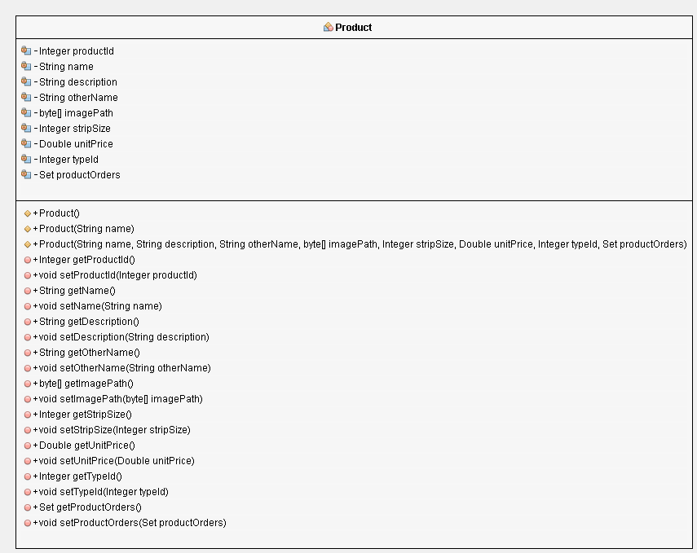

Figure 7 Product Class

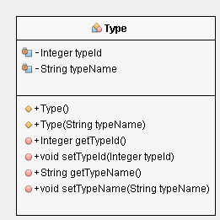

Figure 8 Type Class

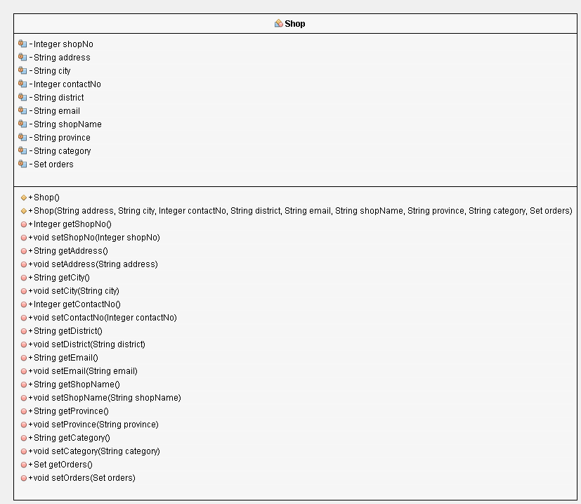

Figure 9 Shop Class

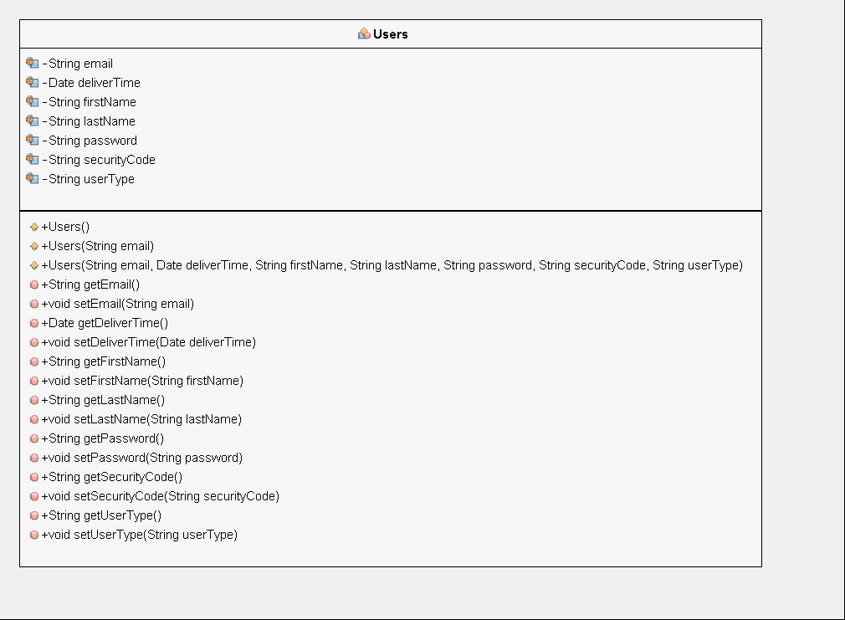

Figure 10 Users Class

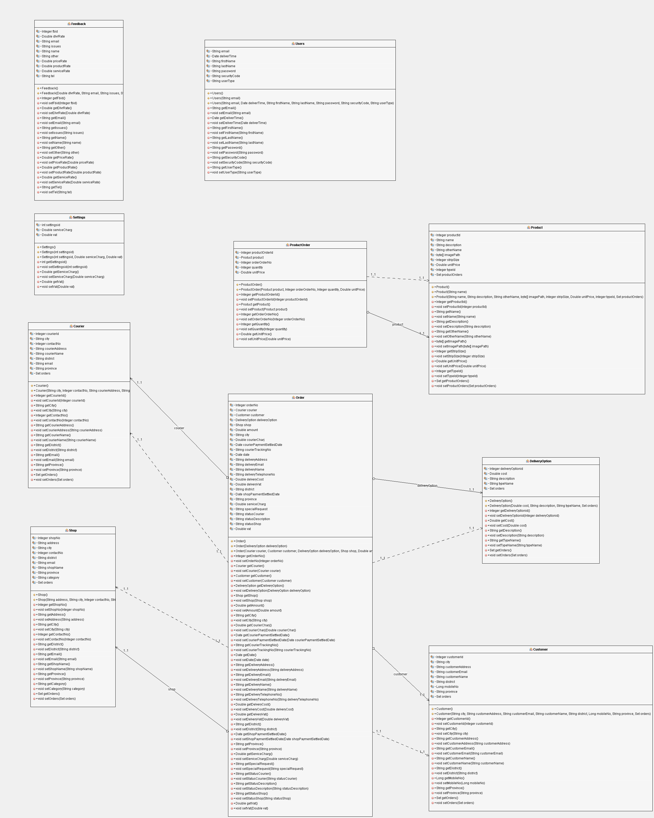

Figure 11 Complete Class Diagram

## Entity Relationship Diagram

# Further Work

As mentioned the previous chapter with the Gantt chart up to Design Phase is completed except the Activity Diagram.

Remaining parts are,

* Drawing the Activity Diagram.
* Completing the backend and then move to user interface design stage.
* Design of user
* Implementation
* User Training
* Preparing the final Documentation.

Activity Diagram is not completed due to the authors knowledge on Activity diagram should be improved in order to complete the activity diagram, Author will soon complete the activity diagram after referring relevant books

# Online Food ordering system process in flow chart

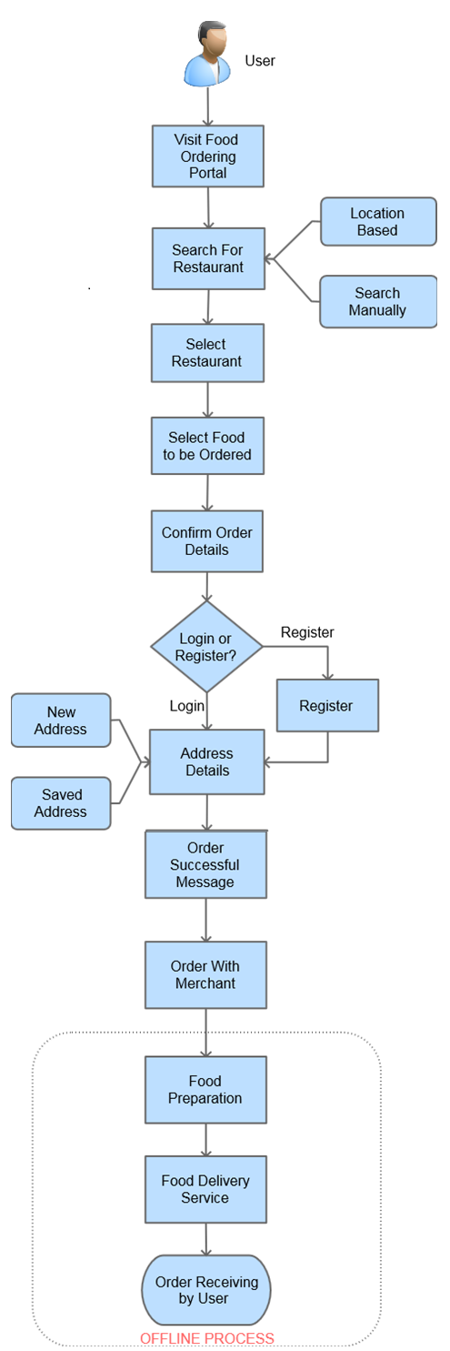External User visit to the Mart the online food ordering system site

Search for a restaurant

Select a restaurant from the listed restaurants that partnered with system

Select food to be ordered.

Place the order.

Confirm order details.

Login to system or sign up if not re

# Bibliography

Online image or video

ANON

In-text: (Anon, 2017)

Your Bibliography: Anon, (2017). [image] Available at: http://criticaltechnology.blogspot.com/2011/09/mvc-in-three-tier-architecture.html [Accessed 1 Apr. 2017].

Book

MEIER, A. AND STORMER, H.

EBusiness & eCommerce

In-text: (Meier and Stormer, 2009)

Your Bibliography: Meier, A. and Stormer, H. (2009). EBusiness & eCommerce. 1st ed. Berlin: Springer.

Website

RAWSTHORNE, P., RAWSTHORNE, P. AND PROFILE, V.

MVC in a three-tier architecture

In-text: (Rawsthorne, Rawsthorne and profile, 2017)

Your Bibliography: Rawsthorne, P., Rawsthorne, P. and profile, V. (2017). MVC in a three-tier architecture. [online] Criticaltechnology.blogspot.com. Available at: http://criticaltechnology.blogspot.com/2011/09/mvc-in-three-tier-architecture.html [Accessed 1 Apr. 2017].

Book

ROEBUCK, K.

Saas - Software as a Service

In-text: (Roebuck, 2012)

Your Bibliography: Roebuck, K. (2012). Saas - Software as a Service. 1st ed. Emereo Publishing.

Book

VON BREITENBUCH, M.

Online Food Shopping: Consumer perception and retailers market approach, contrasting the markets UK and Germany

In-text: (von Breitenbuch, 2004)

Your Bibliography: von Breitenbuch, M. (2004). Online Food Shopping: Consumer perception and retailers market approach, contrasting the markets UK and Germany. Munich: GRIN Verlag GmbH.

Website

WHAT ARE THE ADVANTAGES OF ONLINE FOOD ORDERING

In-text: (Gloriafood.com, 2017)

Your Bibliography: Gloriafood.com. (2017). What are the advantages of online food ordering. [online] Available at: https://www.gloriafood.com/restaurant-ideas/advantages-of-online-food-ordering [Accessed 1 Apr. 2017].

Website

WHAT IS ECOMMERCE?

In-text: (Networksolutions.com, 2017)

Your Bibliography: Networksolutions.com. (2017). What is Ecommerce?. [online] Available at: http://www.networksolutions.com/education/what-is-ecommerce/ [Accessed 1 Apr. 2017].

Book

WOHL, A. D.

Succeeding at SaaS

In-text: (Wohl, 2008)

Your Bibliography: Wohl, A. (2008). Succeeding at SaaS. 1st ed. Bohemia, NY: Wohl Associates.

Book

SOMMERVILLE, I.

Software engineering

In-text: (Sommerville, n.d.)

Your Bibliography: Sommerville, I. (n.d.). Software engineering. 1st ed.